**Week 2**

**Mockito Exercises**

**Exercise 1: Mocking and Stubbing**

1. **ExternalApi.java**

**package** com.example.service;

**public** **interface** ExternalApi {

String getData();

}

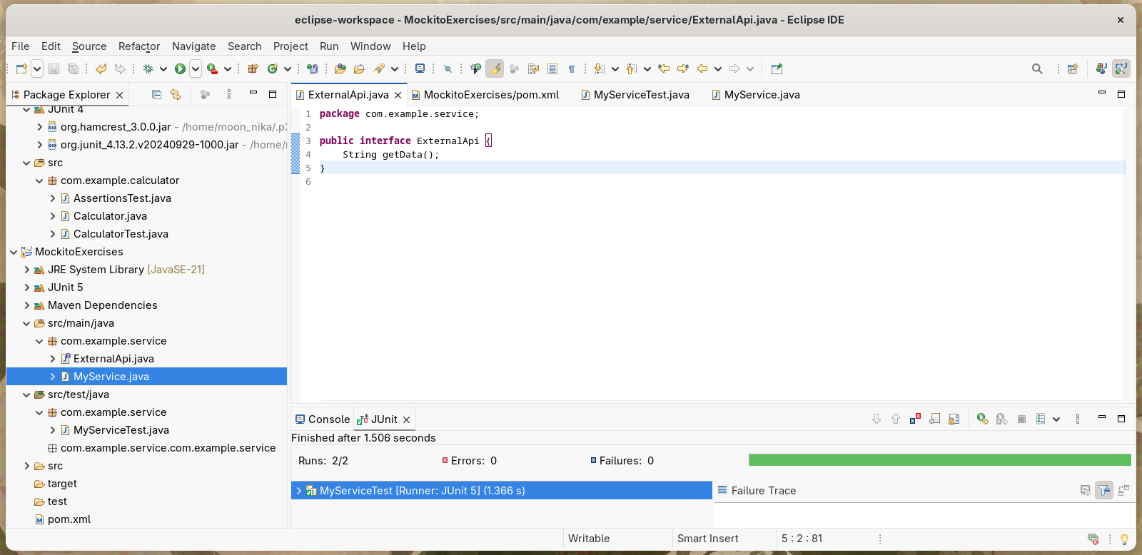

1. **Stub the methods to return predefined values**

**package** com.example.service;

**import** **static** org.mockito.Mockito.*;

**import** org.junit.jupiter.api.Test;

**import** org.mockito.Mockito;

**import** **static** org.junit.jupiter.api.Assertions.*assertEquals*;

**public** **class** MyServiceTest {

@Test

**public** **void** testExternalApi() {

ExternalApi mockApi = Mockito.*mock*(ExternalApi.**class**);

*when*(mockApi.getData()).thenReturn("Mock Data");

MyService service = **new** MyService(mockApi);

String result = service.fetchData();

*assertEquals*("Mock Data", result);

}

}

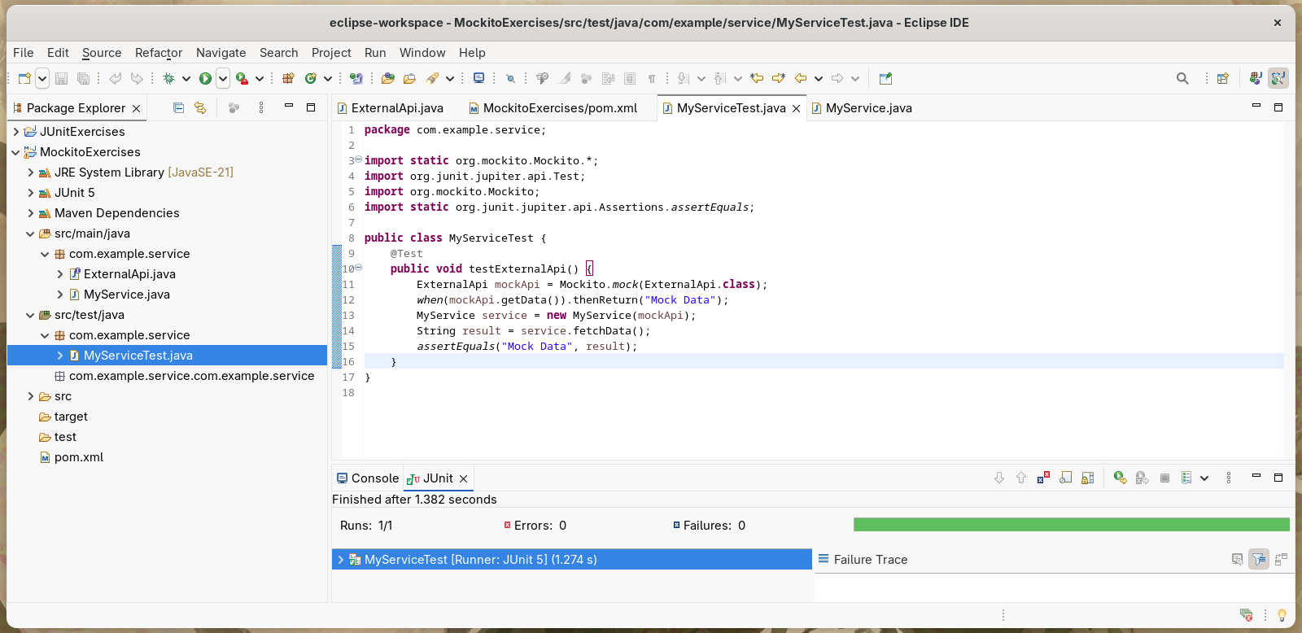

1. **test case**

**package** com.example.service;

**public** **class** MyService {

**private** ExternalApi api;

**public** MyService(ExternalApi api) {

**this**.api = api;

}

**public** String fetchData() {

**return** api.getData();

}

}

